Supplementary

Fig. S1. Low-resolution SEM images of AgNP conductive structures (Two times single print with plasma and immediate post-inert plasma treatment after each print) on PDMS printed with a plasma voltage of a) 11kV, b) 14kV, c) 17kV, d) 20kV, e) 23kV.

Fig. S2. High-resolution SEM images of AgNP conductive structures (Two times single print with plasma and immediate post-inert plasma treatment after each print) on PDMS printed with a plasma voltage of a) 11kV, b) 14kV, c) 17kV, d) 20kV, e) 23kV,

Fig. S3. Cross-sectional SEM images of AgNP conductive structures (Two times single print with plasma and immediate post-inert plasma treatment after each print) on PDMS printed with a plasma voltage of a) 11kV, b) 14kV, c) 17kV, d) 20kV, e) 23kV.

Fig. S4. Tilted SEM images of AgNP conductive structures (Two times single print with plasma and immediate post-inert plasma treatment after each print) on PDMS printed with a plasma voltage of a) 11kV, b) 14kV, c) 17kV, d) 20kV, e) 23kV.

Fig. S5. Low-resolution SEM images of AgNP conductive structures on PDMS printed with a) single print without plasma (S1), b) Single print with plasma (S2), c) Single print with plasma, and immediate post-inert plasma treatment (S3), d) Two print with plasma (S4), e) Two times single print with plasma, and immediate post-inert plasma treatment after each print (S5), f) Three print with plasma (S6), g) Three times single print with plasma, and immediate post-inert plasma treatment after each print (S7).

Fig. S6. High-resolution SEM images of AgNP conductive structures on PDMS printed with a) single print without plasma (S1), b) Single print with plasma (S2), c) Single print with plasma, and immediate post-inert plasma treatment (S3), d) Two print with plasma (S4), e) Two times single print with plasma, and immediate post-inert plasma treatment after each print (S5), f) Three print with plasma (S6), g) Three times single print with plasma, and immediate post-inert plasma treatment after each print (S7).

Fig. S7. Cross-sectional SEM images of AgNP conductive structures on PDMS printed with a) single print without plasma (S1), b) Single print with plasma (S2), c) Single print with plasma, and immediate post-inert plasma treatment (S3), d) Two print with plasma (S4), e) Two times single print with plasma, and immediate post-inert plasma treatment after each print (S5), f) Three print with plasma (S6), g) Three times single print with plasma, and immediate post-inert plasma treatment after each print (S7).

Fig. S8. Tilted SEM images of AgNP conductive structures on PDMS printed with a) single print without plasma (S1), b) Single print with plasma (S2), c) Single print with plasma, and immediate post-inert plasma treatment (S3), d) Two print with plasma (S4), e) Two times single print with plasma, and immediate post-inert plasma treatment after each print (S5), f) Three print with plasma (S6), g) Three times single print with plasma, and immediate post-inert plasma treatment after each print (S7).

**Introduction**

We devised a test bench specifically tailored for conducting stretch tests on printed samples, aimed at precisely characterizing the resistance variations during stretching. Fig. S9 illustrates the schematic layout of the test bench setup.

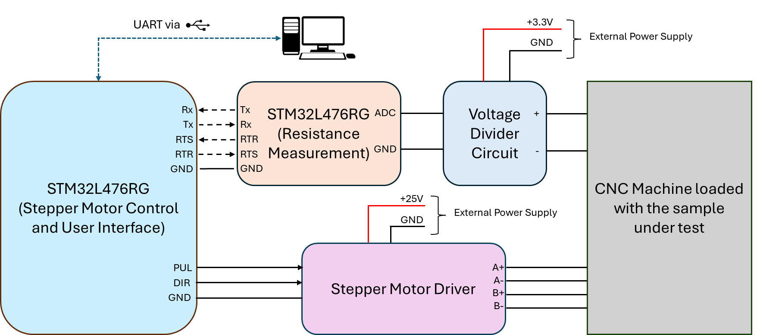

Fig. S9. Schematic representation of the developed test bench for stretch testing.

The system is anchored by two STM32L476RG microcontrollers. The initial microcontroller (referred to as Stepper Motor Control and User Interface, MCU1) is programmed to fulfill the following functions:

* Manage the rotation of the stepper motor linked with the CNC machine.
* Compute and convey resistance measurement parameters to the second microcontroller (referred to as resistance measurement, MCU2).
* Serve as a user interface, facilitating command reception from the user and furnishing real-time system status feedback. A command line interface embedded within this microcontroller streamlines user interaction, obviating the need for microcontroller reprogramming for each test scenario with varying parameters.

The secondary microcontroller (referred to as resistance measurement, MCU2) is tasked with executing Analog-to-Digital Converter (ADC) readings at requested time intervals. The utilization of two distinct microcontrollers allows for the concurrent execution of stretch testing and resistance measurement. A Voltage Divider circuit is deployed to discern the resistance of the sample under evaluation. MCU1 regulates the Stepper Motor Driver to govern the stepper motor's speed and duration as per the test specifications. During the stretch test, the sample is affixed onto the CNC machine for evaluation.

**MCU1, Stepper Motor Control and User Interface**

1. Stepper Motor Driver Control

The Stepper Motor Driver (SMD) is configured to deliver 25,000 pulses for a single 360º rotation of the stepper motor shaft. As specified in its datasheet, the pulse width must be more than 2.5µs. Furthermore, each complete rotation of the stepper motor corresponds to a linear displacement of 5mm (based on the ball screw pitch) on our CNC machine, specifically the SFU1605 CNC machine from RATTMMOTOR. The correlation between pulse width and the linear speed of the CNC machine is delineated as follows:

$$Linear Speed \left(mm/sec\right)=\frac{Ball Screw Pitch*{10}^{6}}{SMD Pulse Selection*Pulse Width (µs)*2}$$

Or,

$$Pulse Width \left(µs\right)=\frac{5*{10}^{6}}{25000*2*Linear Speed (mm/sec)}$$

For Example, we want to run the machine at 20mm/sec, the pulse width shall be:

$$\frac{5*{10}^{6}}{25000*2*20}=5µs$$

This signifies that when the microcontroller emits 25,000 pulses with a pulse width of 5µs and a 50% duty cycle, the CNC machine's block will advance 5mm, at a speed of 20mm/sec. It's noteworthy that if, instead, 12,500 pulses were dispatched with the same pulse width and duty cycle, the block would progress 2.5mm, corresponding to a half rotation.

The principles elucidated above underpin the development of low-level functions for pulse width computation and pulse emission based on user-requested speed and displacement. This is accomplished by configuring and operating timers to ensure precise pulse widths. These pulses are directed to the PUL pin on the Stepper Motor Driver. The direction of rotation is governed by setting the DIR pin to either HIGH or LOW.

1. Resistance measurement parameters computation

One of the user-input parameters crucial for conducting stretch tests is the number of resistance (or ADC) readings required during a single test iteration (where one test iteration involves stretching the sample to the specified displacement at the designated speed and then returning it). For instance, if the user specifies stretching the sample by 1mm at a speed of 20mm/sec, with a stretch hold time of 0ms, and acquiring 100 resistance readings, this implies that the ADC on MCU2 must execute 100*4 readings (utilizing a running average of 4 to account for brief fluctuations) throughout the test duration.

It's essential to note that it takes 64µs to conduct 4 readings and calculate their average on MCU2. Consequently, MCU2 must incorporate a computed delay between successive ADC readings. This delay is achieved by employing timers to ensure precise timing, with a tolerance of ±0.1µs.

The computation for the time delay or timer duration between ADC readings is outlined as follows:

$$Timer Run Time \left(µs\right)$$

$$=\frac{\left[\frac{Displacement \left(mm\right)}{Speed (mm/sec)}*{10}^{6}*2+Stretch hold time\left(ms\right)*{10}^{3} \right]}{Number of ADC readings requested}$$

$$-\frac{\left[Number ofADC readings requested*ADC run time\right]}{Number of ADC readings requested}$$

For the example considered earlier, i.e. displacement = 1mm, speed = 20mm/sec, stretch hold time of 0ms, and number of ADC readings = 100, the timer run time shall be:

$$Timer Run Time \left(µs\right)=\frac{\left[\frac{1}{20}*{10}^{6}*2+0\right]-\left[100*64\right]}{100}=\frac{{10}^{5}-6400}{100}=\frac{93600}{100}=936µs$$

The calculation of this timer runtime is conducted on MCU1 and transmitted to MCU2, alongside the specified number of ADC readings required, prior to commencing each stretch test. Subsequently, MCU2 executes this timer loop iteratively based on the user's request for the number of stretch tests.

1. Command Line Interface

MCU1 is equipped with a Command Line Interface (CLI) designed to accept commands via UART2 (operating at 921600 baud rate), enabling interaction with any serial terminal software. The following commands are supported by MCU1:

* HELP

Displays all available commands that MCU1 can process, accompanied by examples.

* SHOW CURRENT LOC

Retrieves and displays the current location of the block on the CNC machine. Upon reset, MCU1 initializes the block's location at 34mm on the left corner.

* SET CURRENT LC LOC arg1

Sets the current location of the left corner of the block to the specified value (arg1), where arg1 represents the distance in millimeters (mm).

* SET CURRENT RC LOC arg1

Sets the current location of the right corner of the block to the specified value (arg1), where arg1 represents the distance in millimeters (mm).

* GOTO LC LOC arg1

Moves the left corner of the block to the specified position (arg1), where arg1 represents the location in millimeters (mm).

* GOTO RC LOC arg1

Moves the right corner of the block to the specified position (arg1), where arg1 represents the location in millimeters (mm).

* STERTCH LEFT arg1 arg2 arg3 arg4 arg5

arg1 = displacement (mm)

arg2 = speed (mm/sec)

arg3 = Number of stretch tests

arg4 = stretch hold time (ms)

arg5 = number of ADC readings

Upon receiving this command, MCU1 executes the following actions:

Computes the pulse width for the Stepper Motor Driver (SMD) based on arg1 and arg2.

Computes the timer runtime on MCU2 based on arg1, arg2, arg4, and arg5.

Communicates the timer runtime and the number of ADC readings to MCU2, awaiting acknowledgement. MCU2 acknowledges once peripherals are initialized, commencing ADC readings and timer-based delays until the specified number of readings is reached.

Moves the block to the LEFT based on arg1 and arg2 upon receiving acknowledgement from MCU2.

Holds the block at the designated displacement location until the stretch hold timer elapses.

Returns the block to its initial position based on arg1 and arg2, marking the completion of one stretch test.

Requests all ADC readings from MCU2, receiving and processing the measured values until completion.

Converts the unsigned 12-bit integer (ADC reading) to measured resistance and outputs the value on the serial monitor.

Repeats steps (iii) through (viii) until the specified number of stretch tests (arg3) is achieved.

MCU1 becomes ready to receive new commands from the user.

* STERTCH RIGHT arg1 arg2 arg3 arg4 arg5

Functions similarly to STRETCH LEFT, but initiates stretching towards the RIGHT side from the current position, followed by returning to the initial position.

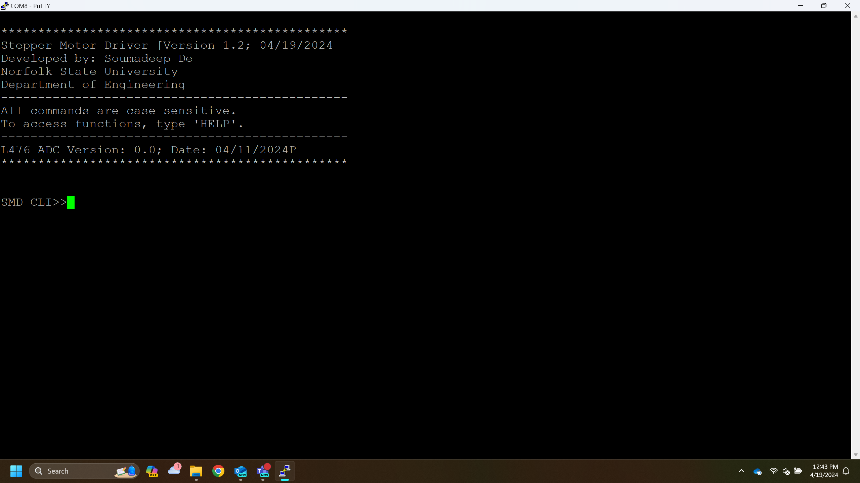

Fig. S10. Command Line Interface

**MCU2, Resistance Measurement**

MCU2 is configured to accept commands via UART1 (operating at 921600 baud rate), allowing command transmission via any serial terminal software, or in our case, from MCU1. MCU2 recognizes the following commands:

* CONNECTION CHECK

Upon receiving this command, MCU2 promptly responds with "firmware version"_"firmware date".

* START ADC arg1 arg2

arg1 = Number of ADC readings requested

arg2 = Timer run time in µs.

Upon receipt of this command, MCU2 executes the following functions:

1. Conducts ADC1 calibration.
2. Initializes the timer based on the specified timer run time.
3. Sends an acknowledgment (ACK) followed by a "\r" escape sequence to MCU1.
4. Initiates ADC readings, followed by timer-based delays, until the requested number of readings is obtained.
5. Upon completing the readings, MCU2 becomes ready to accept new commands while retaining the ADC readings.

* SEND DATA

MCU2 transmits all ADC measurements to MCU1, with each reading followed by a "\r" escape sequence to signify the end of one reading. Once all data is transmitted, MCU2 transitions to a state where it is now ready to accept new commands.

**MCU1, Clock Configuration**

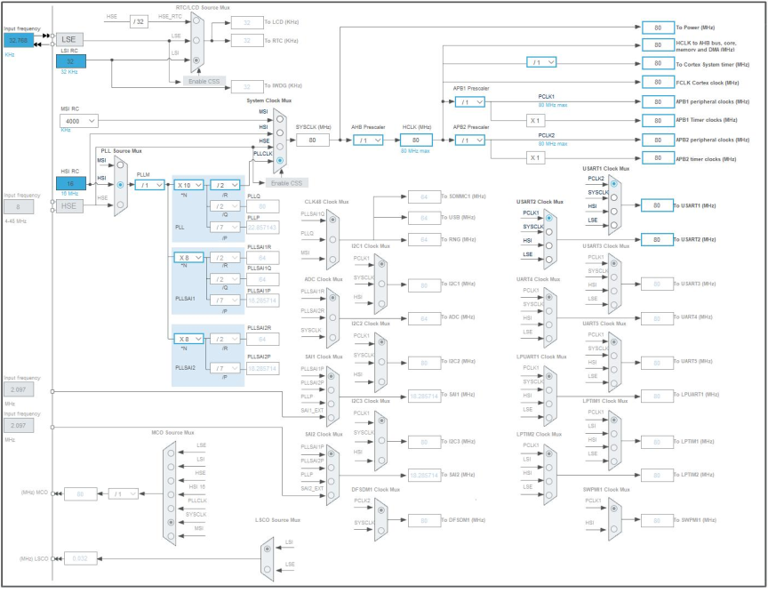

Fig. S11. Clock Configuration for MCU1

**MCU2, Clock Configuration**

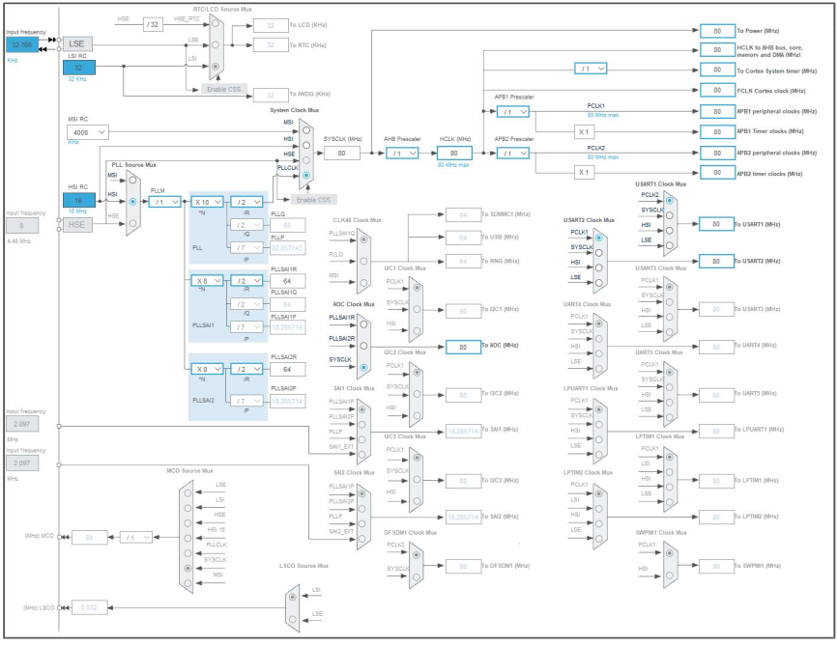

Fig. S12. Clock Configuration for MCU2

**Voltage Divider Circuit**

The voltage divider circuit has been configured as follows:

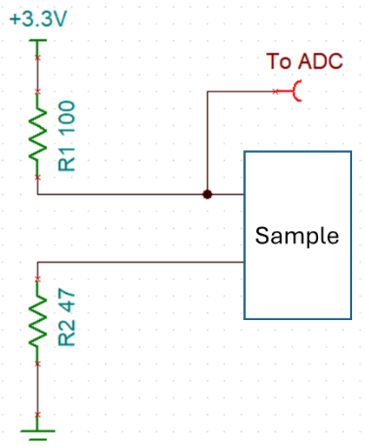

Fig. S13. Voltage Divider Circuit Setup

$$R_{sample}=\frac{R_{1}}{\left[\frac{V_{in}}{V_{meas}}-1\right] }-R_{2}$$

$$R_{sample}=\frac{R_{1}}{\left[\frac{3.3}{\frac{ADC data }{4095}*3.3}-1\right] }-R_{2}$$

$$R_{sample}=\frac{R_{1}}{\left[\frac{4095}{ADC data}-1\right] }-R_{2}$$